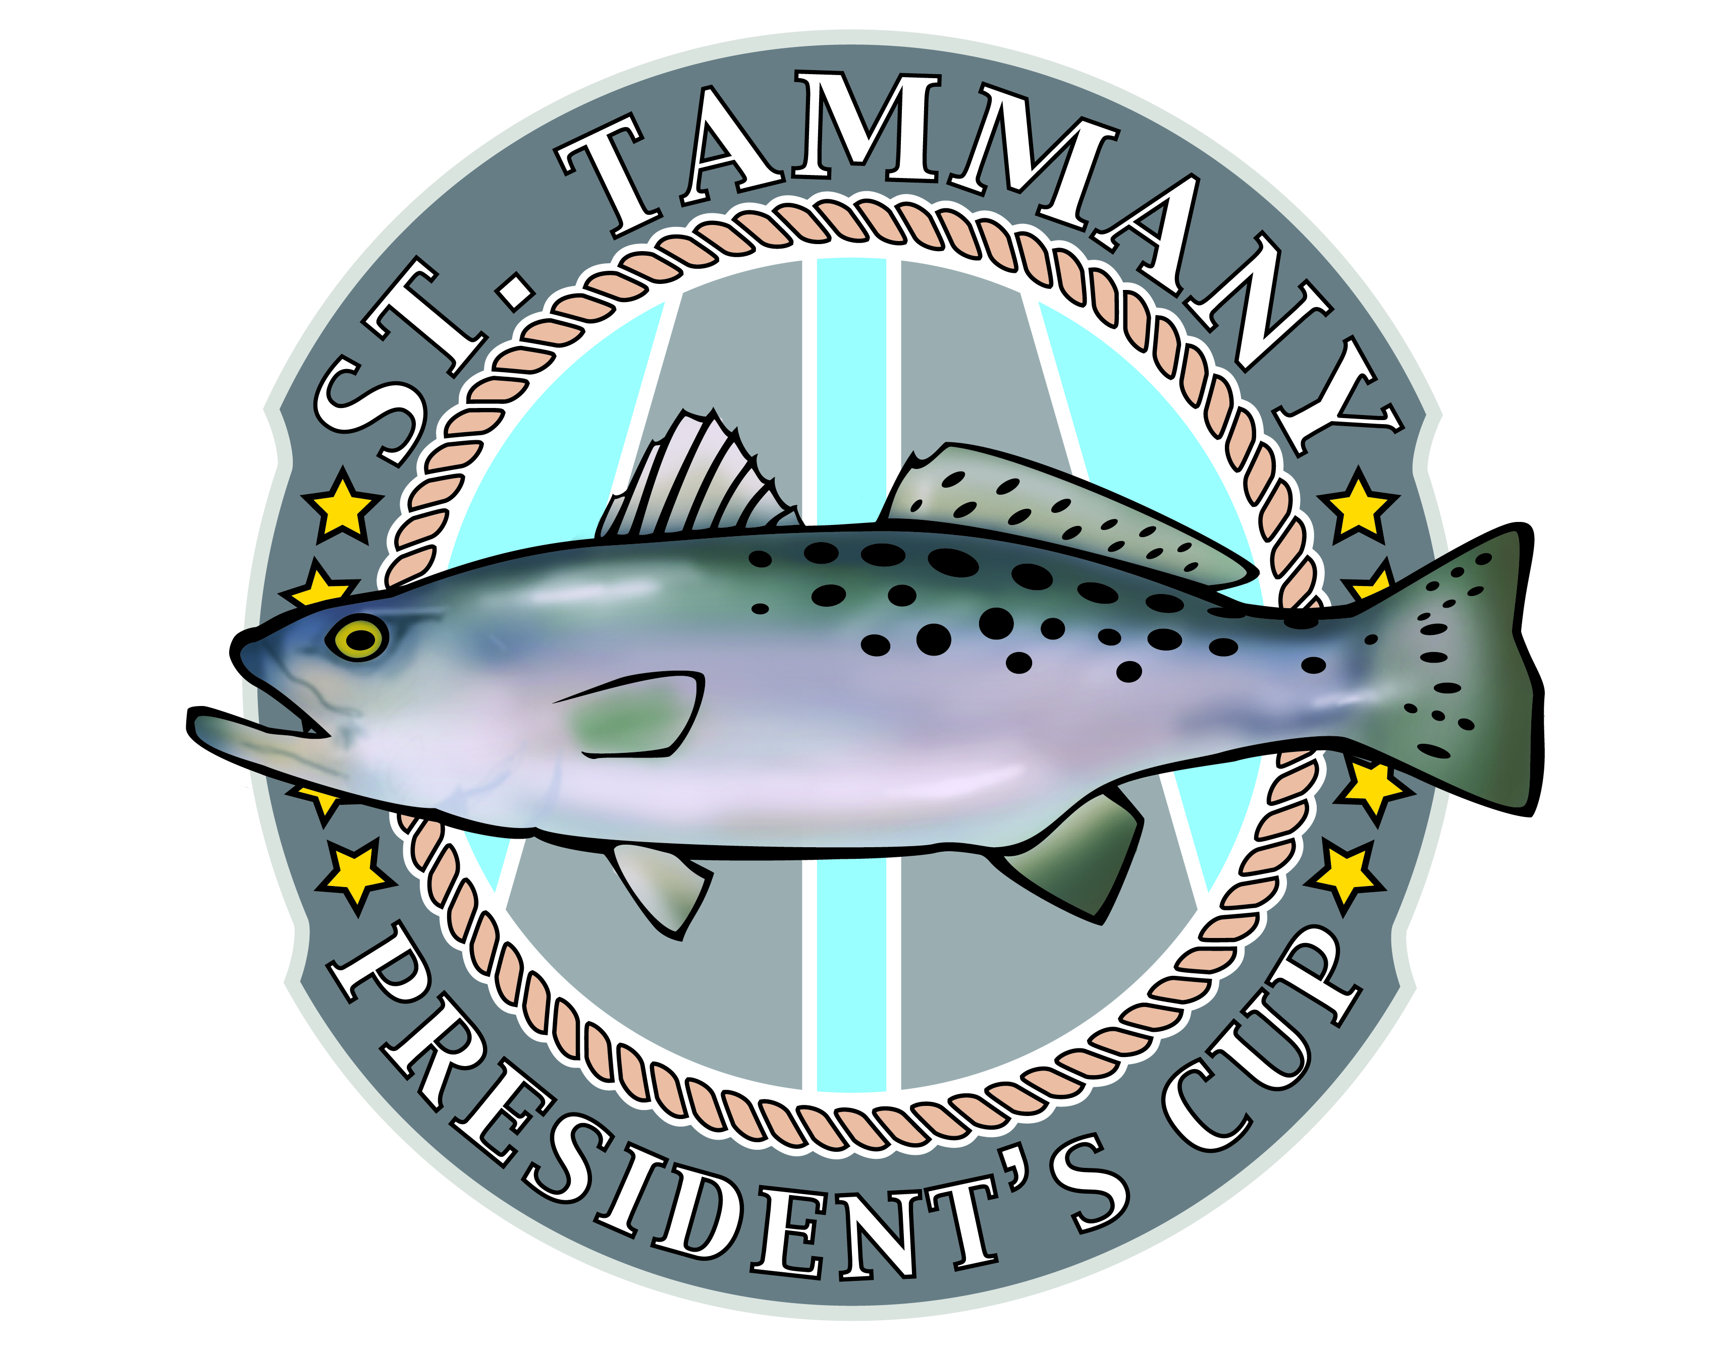
President’s Cup
Fishing Tournament Rules
2015

- All rodeo participants must abide by State of Louisiana laws regarding proper fishing licenses, fish size minimums, and any applicable fishing laws.
- A maximum of four anglers are allowed per team and must all be in one boat.
- Each team will bring in and weigh their biggest fish from the following categories: Redfish, Speckled Trout, Black Drum, Sheepshead, and Flounder. Points will be awarded based on the place the fish weighs in at: 1st place- 3pts, 2nd place -2pts, 3rd place -1 pt.
- Teams do not have to bring in five fish to win the tournament. For example, if a team only brings in first place redfish and black drum and the total points are more than a team having all five species 3rd place fish the team with the redfish and black drum wins (6 to 5).
- In the event of a tiebreaker, the tied team’s redfish with the highest weight will be awarded the prize. If that also results in a tie or if no redfish is caught, the team with the highest weight fish will be awarded the prize.
- All contestants must register before they begin fishing at dawn. You may leave from The Dock in Slidell or any dock your team chooses. Boats at The Dock will enter the water in order of registration.
- All competitive fishing shall begin at dawn on Saturday, October 10th with all fish at the weigh station no later than 1pm. Scales will open at noon. All fish must be checked by the Weigh Master. Fish may be weighed either alive or dead.
- Fish may be caught using any type of rod and reel combo. Fish MAY NOT be caught using cast nets or other nets or by any other means (gaffed, gill/shrimp netted, caged, box/slat trapped).
- Louisiana Department of Wildlife and Fisheries’ biologists will weigh and tally fish from each team to determine the winner.
- All decisions of the Louisiana Wildlife and Fisheries Weigh Master will be final. The condition of all fish and rules of the Rodeo to ensure sportsmanship is entirely subject to the Weigh Master’s decision.
- Once the tournament winner has been decided, each of the teams will be provided the Tax ID number and contact information for the winning team’s charity of choice. The check for the entry fee will be made payable to the winning team’s charity.
- Participants enter at their own risk. Neither the St. Tammany Parish Government, nor any person connected with the rodeo, shall be liable for any loss, damage, negligence, harm or injury to anyone for any reason.

